2A2B HUMAN BIOLOGY CELL TRANSPORT & DNA TEST

Name:_____________________________ /36

**Part one – multiple choice**

*Circle the correct answer*

1. Osmosis is a special type of diffusion that deals with the movement of water molecules through a selectively permeable membrane from:

a) An area of low solute concentration to an area of high solute concentration.

b) An area of high solute concentration to an area of low solute concentration.

c) An area of diffusion to an area of low osmotic pressure.

d) An area inside an egg to an area outside an egg.

2. The organelle required for translation of mRNA is:

a) A ribosome.

b) The endoplasmic reticulum.

c) The nucleus.

[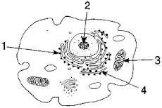](http://www.google.com.au/imgres?um=1&hl=en&biw=1920&bih=931&tbm=isch&tbnid=U89ZmWMusBTYbM:&imgrefurl=http://www.edhsgreensea.net/Biology/taters/cell_parts_quiz_mc.htm&docid=TBrWfSSVlWYqlM&imgurl=http://www.edhsgreensea.net/Biology/taters/taters_images/cell_pic.gif&w=288&h=193&ei=dlE9Ub6OCMjIkQWGxYGYDg&zoom=1&ved=1t:3588,r:78,s:0,i:319&iact=rc&dur=15069&page=3&tbnh=154&tbnw=230&start=76&ndsp=42&tx=101&ty=60) d) Transfer RNA.

The following two questions refer to the diagram to the right

3. DNA can be found in which organelle/s:

a) 1

b) 2

c) 3

d) 2 & 3

4. Which of the following contains the correct name and function for #4

a) The cytoskeleton connects the cell membrane with the nuclear membrane and provides a surface for chemical reactions

b) The endoplasmic reticulum connects the cell membrane with the nuclear membrane and provides a surface for chemical reactions

c) The cytoskeleton consists of microtubules which give the cells its shape and assist with movement of materials

d) The endoplasmic reticulum consists of microtubules which give the cells its shape and assist with movement of materials

5. Which of the following explains the correct differences between DNA and RNA

a) DNA is single stranded while RNA is double stranded

b) DNA contains thymine while RNA contains Uracil

c) DNA contains nucleotides while RNA does not

d) DNA is only found in the nucleus while RNA is also found in the mitochondria

6. The following is a list of processes which may occur in a cell.

i) active transport.

ii) catabolism.

iii) respiration.

iv) osmosis.

v) anabolism.

vi) diffusion.

vii) pinocytosis.

Which processes listed above move material into, or out of, the cell?

a) iv and vi only.

b) i ,ii and v only.

c) ii, iii, v and vii only.

d) i ,iv, vi and vii only.

7. Pinocytosis is the:

a) movement of solids through a semi permeable membrane.

b) the engulfing of liquids by the cell membrane.

c) the movement of liquids out of the cell.

d) the production of pinoplasts to remove wastes from a cell.

8. Choose the incorrect statement.

a) Most cells in your body have a nucleus.

b) Inside the nucleus are structures called chromosomes.

c) Chromosomes are tightly coiled RNA strands.

d) DNA is a chemical made up of nucleotides.

9. Select the correct pairing of nitrogenous bases found in DNA.

a) Uracil and cytosine.

b) Thymine and adenine.

c) Cytosine and adenine.

d) Guanine and thymine.

10. Select the correct definition for ‘gene’.

a) A section of DNA.

b) Tightly coiled up strand of DNA.

c) Three pairs of nucleotides attached together.

d) DNA located in the mitochondria.

11. What is the correct term for a strand of DNA coiled around histones.

a) Chromosome

b) Chromatin

c) Centromere

d) DNA does not coil around histones

**Part two – short answer**

1. Describe two **differences** between nuclear DNA and mitochondrial DNA.

___________________________________________________________________________________________

___________________________________________________________________________________________

___________________________________________________________________________________________

___________________________________________________________________________________________

___________________________________________________________________________________________

(4 marks)

2. Below is a diagram of a cell membrane.

a What is the term given to the structure of membranes within the cell? (1 mark)

b What are the structures embedded in the membrane? (1 mark)

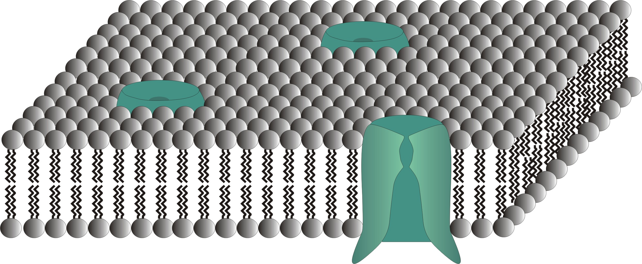

c How do these structures enable large molecules such as glucose to pass through the membrane and what is this process called ? You may use a diagram if you wish. (3 marks)

___________________________________________________________________________________________

___________________________________________________________________________________________

___________________________________________________________________________________________

___________________________________________________________________________________________

___________________________________________________________________________________________

3. Explain why cells are so small. (2 marks)

___________________________________________________________________________________________

___________________________________________________________________________________________

___________________________________________________________________________________________

___________________________________________________________________________________________

___________________________________________________________________________________________

Part three – extended answer

1. With a suitable diagram explain how the synthesis of proteins by ribosomes is controlled by DNA in the nucleus. (14 marks)

___________________________________________________________________________________________

___________________________________________________________________________________________

___________________________________________________________________________________________

___________________________________________________________________________________________

___________________________________________________________________________________________

___________________________________________________________________________________________

___________________________________________________________________________________________

___________________________________________________________________________________________

___________________________________________________________________________________________

___________________________________________________________________________________________

___________________________________________________________________________________________

___________________________________________________________________________________________

___________________________________________________________________________________________

___________________________________________________________________________________________

___________________________________________________________________________________________

___________________________________________________________________________________________

___________________________________________________________________________________________

___________________________________________________________________________________________

___________________________________________________________________________________________

___________________________________________________________________________________________

___________________________________________________________________________________________

___________________________________________________________________________________________

___________________________________________________________________________________________

___________________________________________________________________________________________

___________________________________________________________________________________________

___________________________________________________________________________________________

___________________________________________________________________________________________

___________________________________________________________________________________________

___________________________________________________________________________________________

___________________________________________________________________________________________

___________________________________________________________________________________________

___________________________________________________________________________________________

___________________________________________________________________________________________

___________________________________________________________________________________________

___________________________________________________________________________________________

___________________________________________________________________________________________

___________________________________________________________________________________________

___________________________________________________________________________________________

___________________________________________________________________________________________

___________________________________________________________________________________________

___________________________________________________________________________________________

___________________________________________________________________________________________

___________________________________________________________________________________________

___________________________________________________________________________________________

___________________________________________________________________________________________

___________________________________________________________________________________________

___________________________________________________________________________________________

___________________________________________________________________________________________

___________________________________________________________________________________________

___________________________________________________________________________________________

___________________________________________________________________________________________

______________________________________________________________________________________________________________________________________________________________________________________

___________________________________________________________________________________________

___________________________________________________________________________________________

___________________________________________________________________________________________

___________________________________________________________________________________________

___________________________________________________________________________________________

___________________________________________________________________________________________

___________________________________________________________________________________________

___________________________________________________________________________________________

___________________________________________________________________________________________

___________________________________________________________________________________________

___________________________________________________________________________________________

___________________________________________________________________________________________

___________________________________________________________________________________________

___________________________________________________________________________________________